**MA 374 - Financial Engineering Lab09**

**Sahil Kumar Gupta**

**200123081**

**Q1**

Data for following companies (from nsedata1) are taken for the analysis:

1. NSE Index (NIFTY 50)
2. HDFCBANK.NS
3. ICICIBANK.NS
4. INFY.NS
5. WIPRO.NS

**Q2 -a**

**NIFTY**

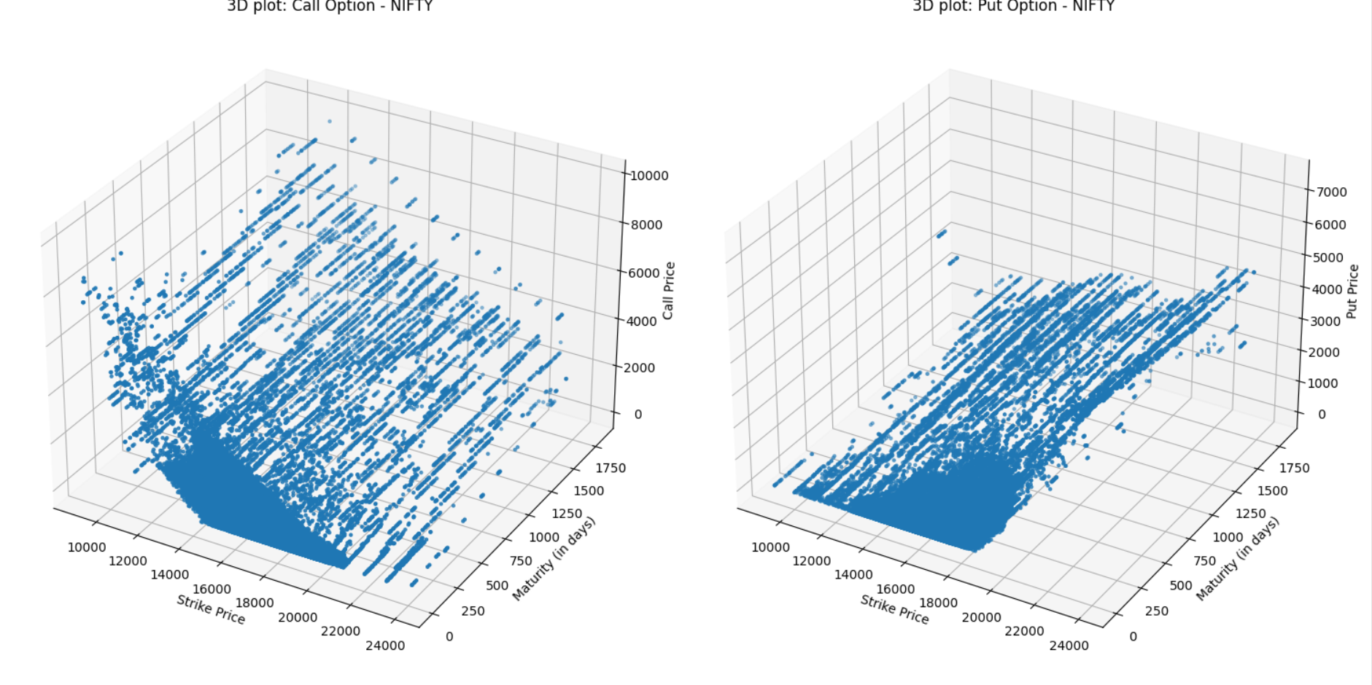

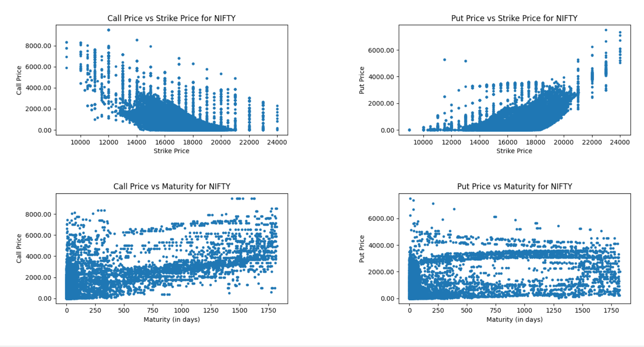

**HDFCBANK.NS**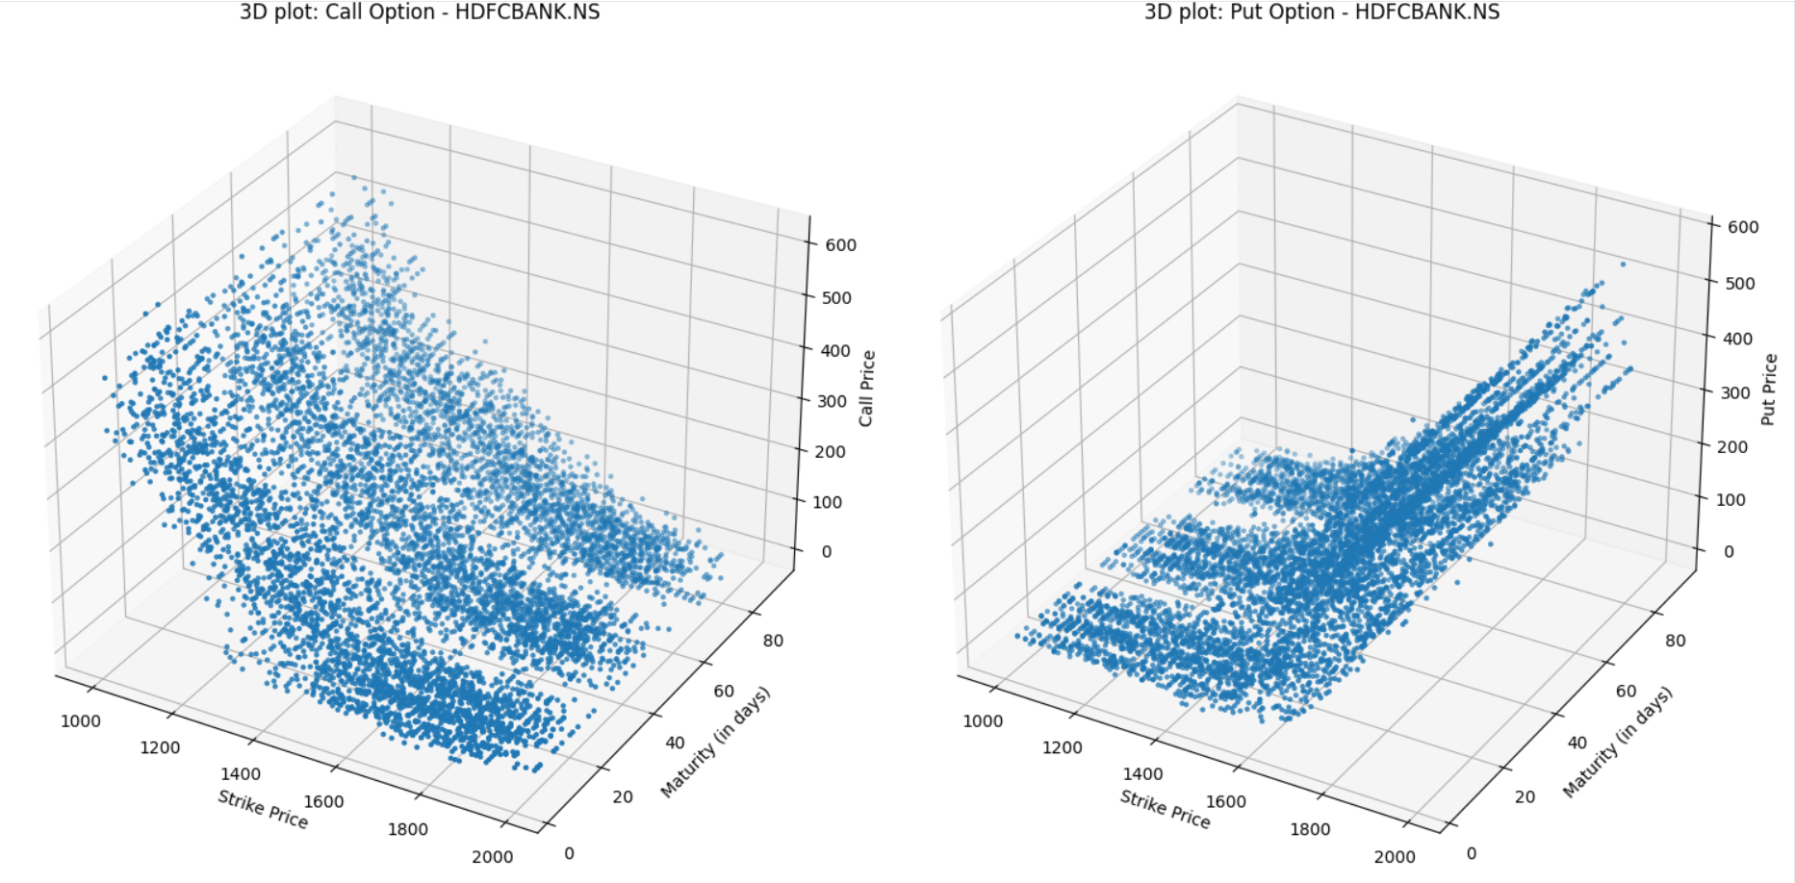 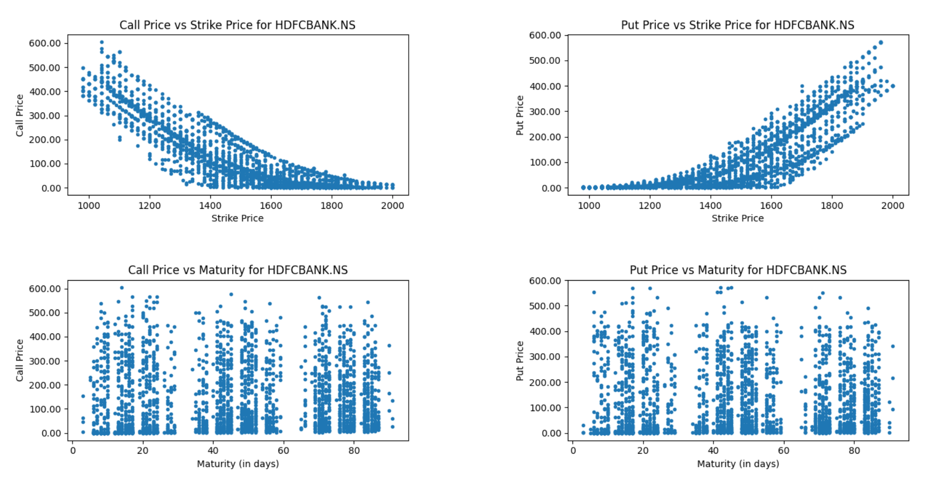

**ICICIBANK.NS**

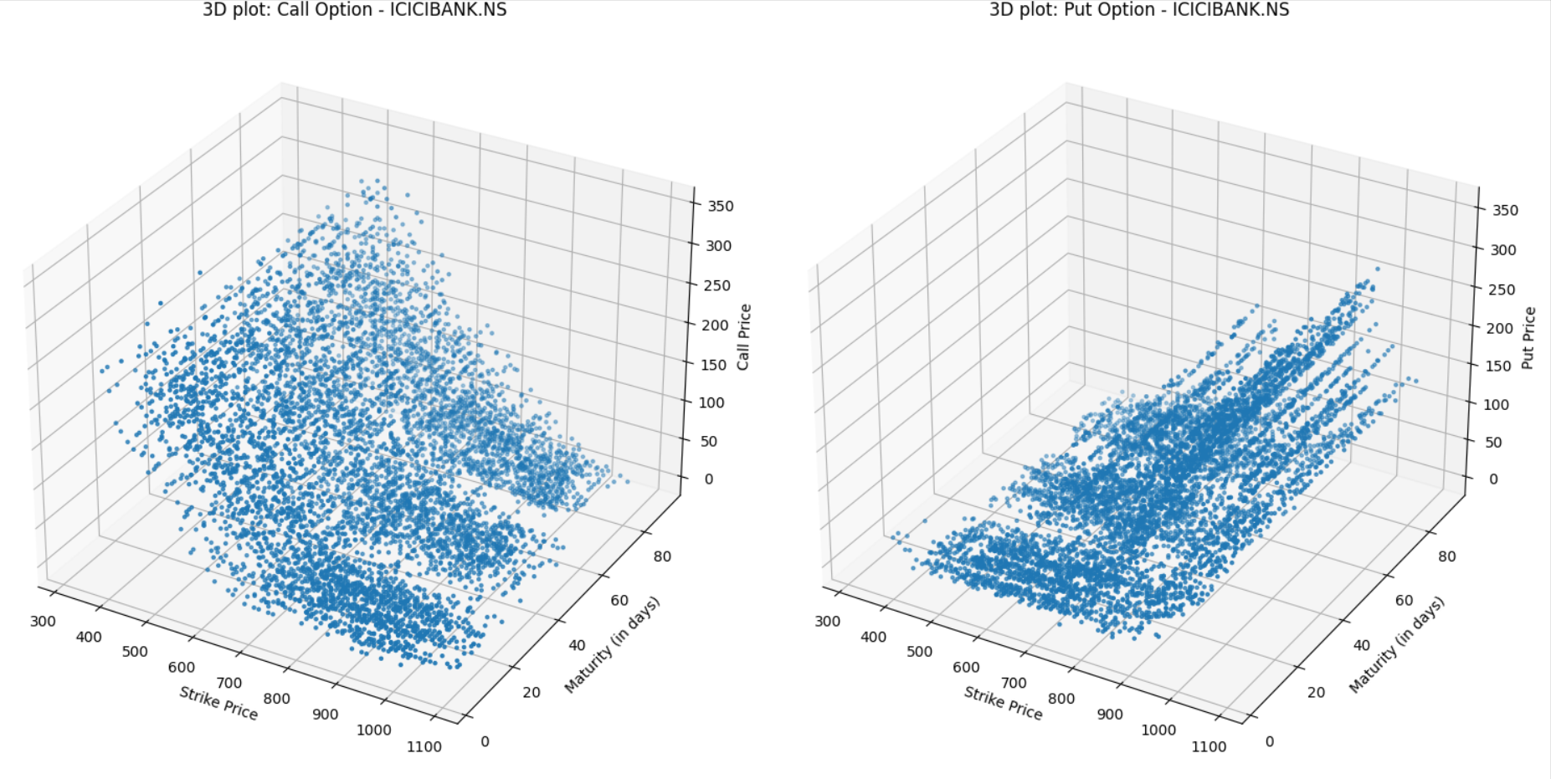 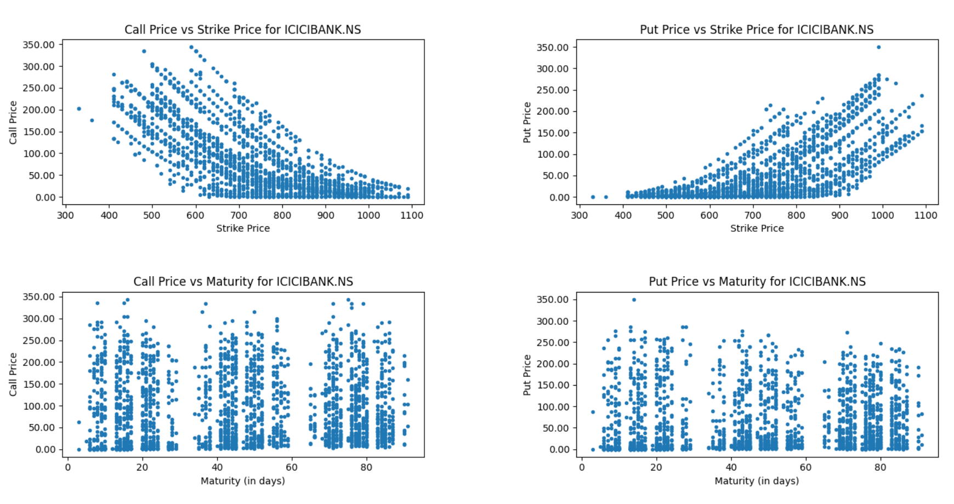

**INFY.NS**

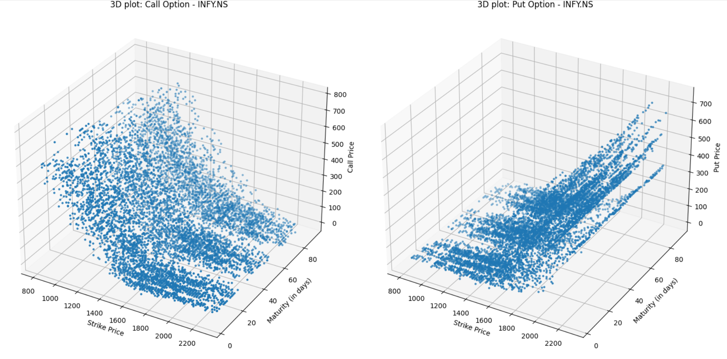 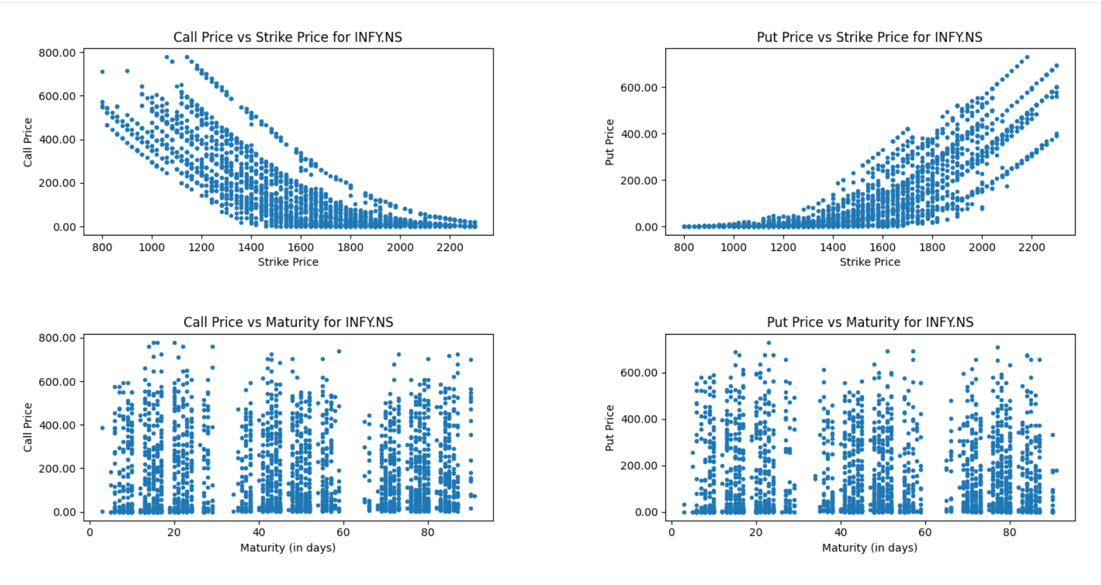

**WIPRO.NS**

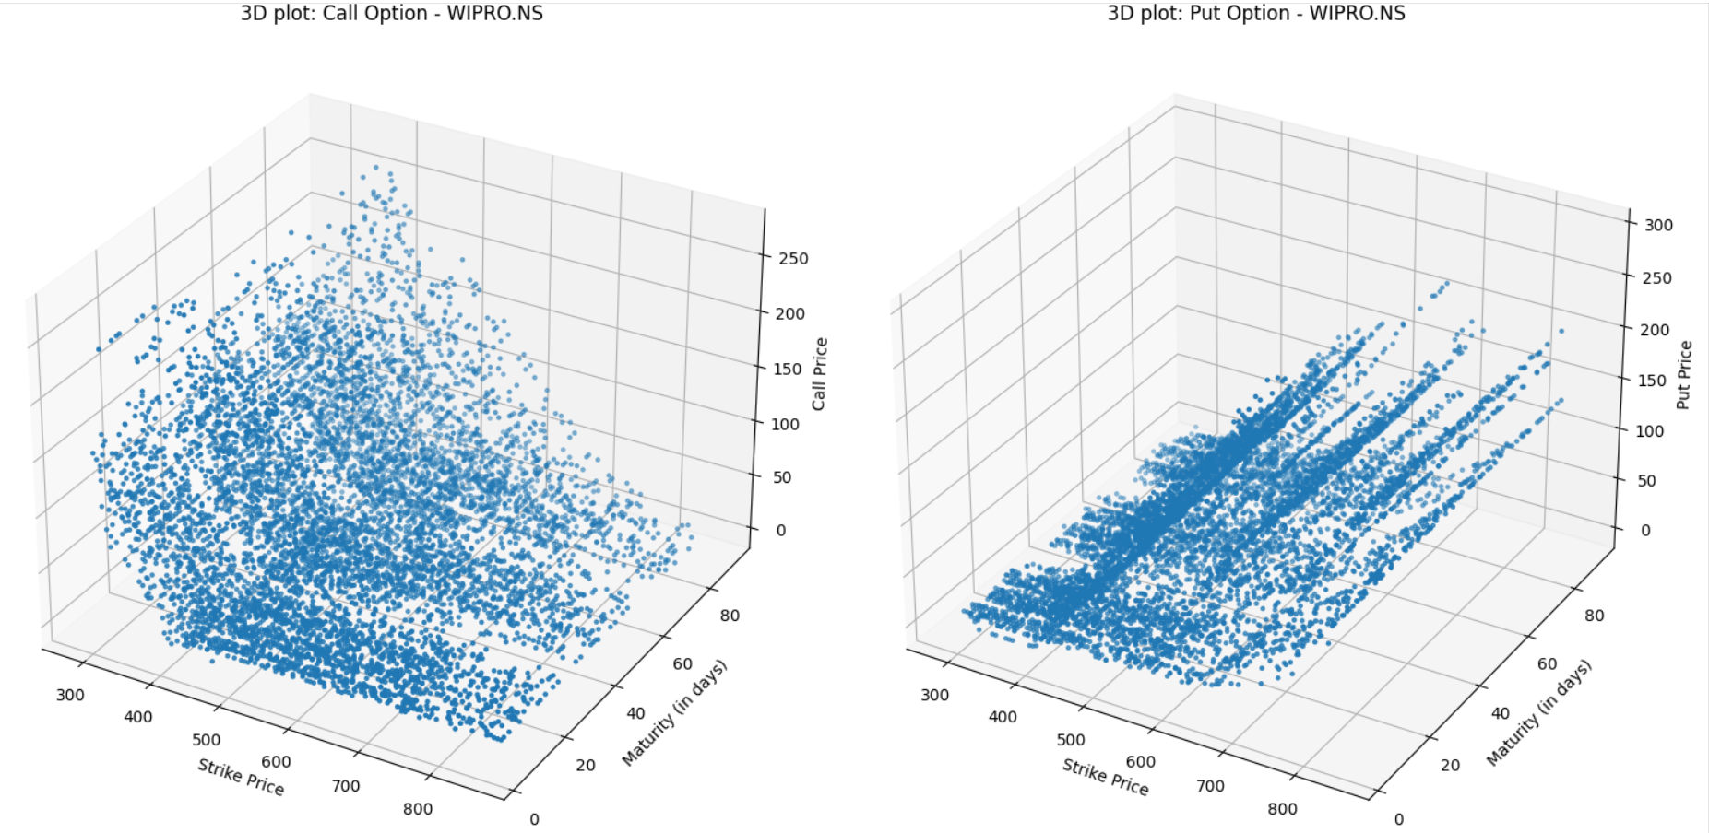

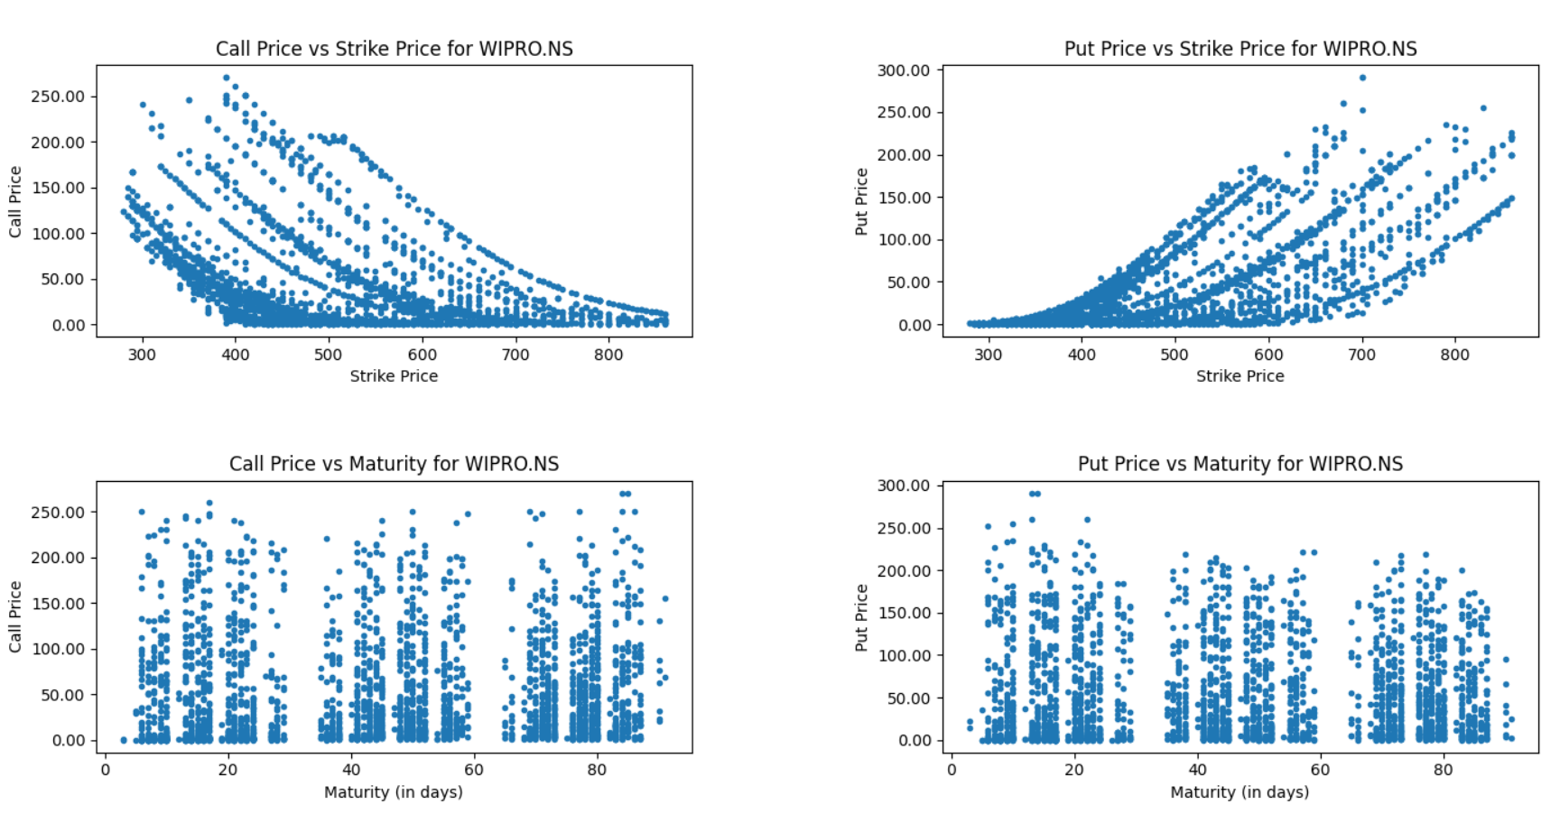

**Observations:**

1. Making accurate analyses becomes challenging due to the lack of sufficient data, but it is possible to identify general trends by examining the NIFTY50 plots, which have more data points. The other plots also demonstrate similar patterns.
2. We can observe a consistent trend where the price of call options decreases while that of put options increases as the strike price rises. This pattern aligns with our expectations.
3. However, the plots for call and put options do not precisely match our expectations. In general, we expect the price of call options to increase and the price of put options to decrease with a longer maturity period.

**Q2-b**

Newton-Raphson method is used to find out the implied volatility from the BSM formula. This method takes the following form:

where,

$$σ_{n+1}=σ_{n}-\frac{F\left(σ_{n}\right)}{F^{'}\left(σ_{n}\right)}$$

$$\begin{matrix} & F(σ)=C(σ)-C^{*} \\ & C(σ)= \text{BSM formula with} σ \text{as unknown parameter} \\ & C^{*}= \text{Observed call option price} \end{matrix}$$

The price of European Call Option given by BSM framework obtained after solving Black-Scholes-Merton PDE is:

$$C(x,t)=xN\left(d_{1}\right)-Ke^{-r(T-t)}N\left(d_{2}\right)$$

where,

$$\begin{matrix} & d_{1}=\frac{log⁡\left(\frac{x}{K}\right)+\left(r+\frac{1}{2}σ^{2}\right)(T-t)}{σ\sqrt{T-t}} \\ & d_{2}=\frac{log⁡\left(\frac{x}{K}\right)+\left(r-\frac{1}{2}σ^{2}\right)(T-t)}{σ\sqrt{T-t}} \\ & N(x)=\frac{1}{\sqrt{2π}}\int_{-∞}^{x}{ } e^{-\frac{1}{2}y^{2}}dy\end{matrix}$$

**NIFTY50**

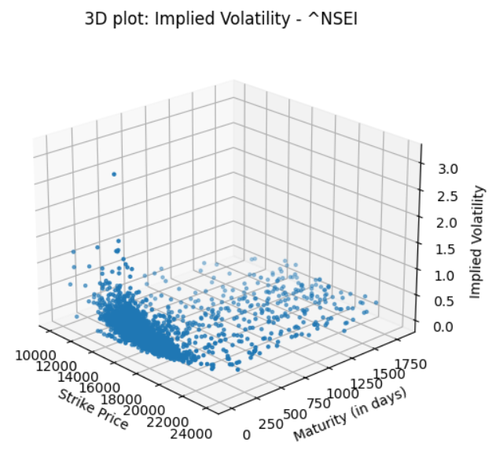

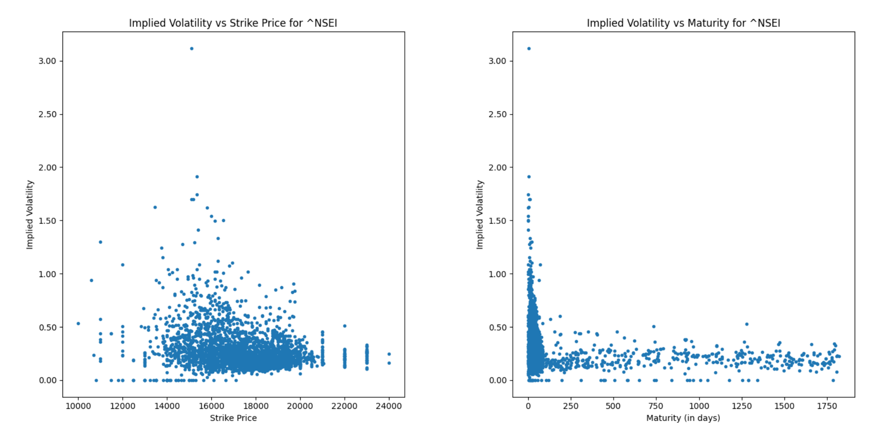

**HDFCBANK.NS**

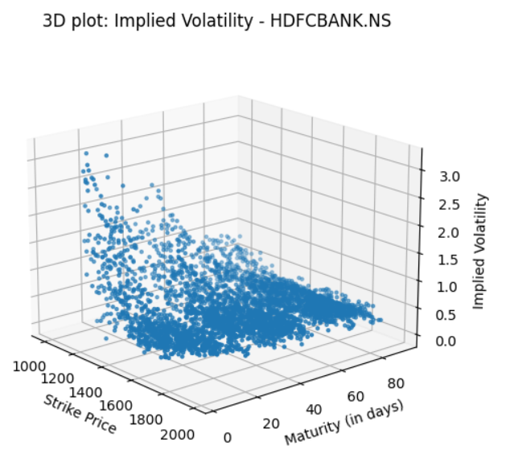

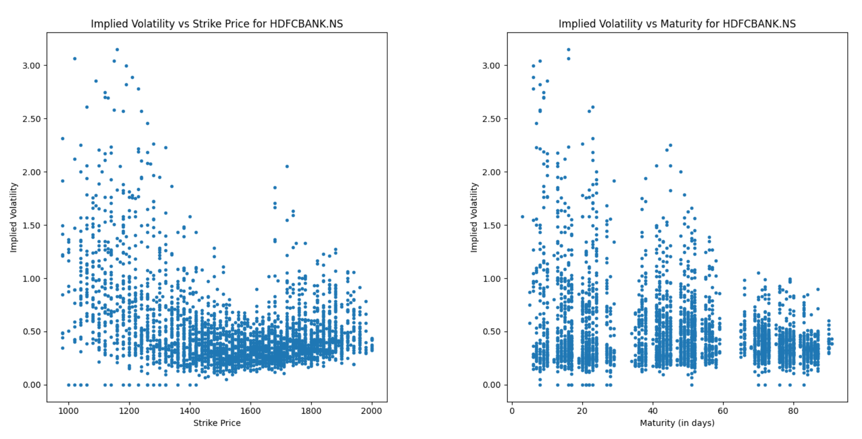

**ICICIBANK.NS**

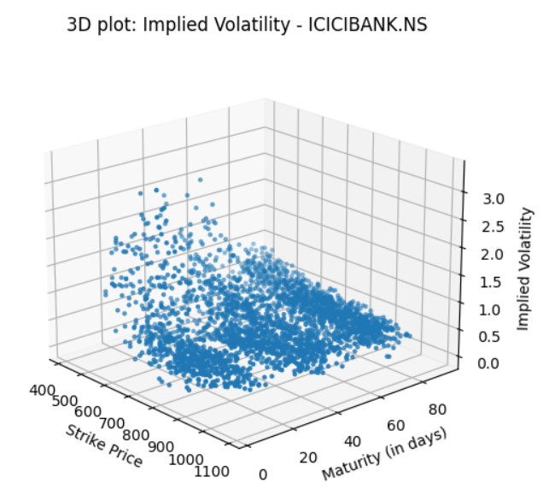 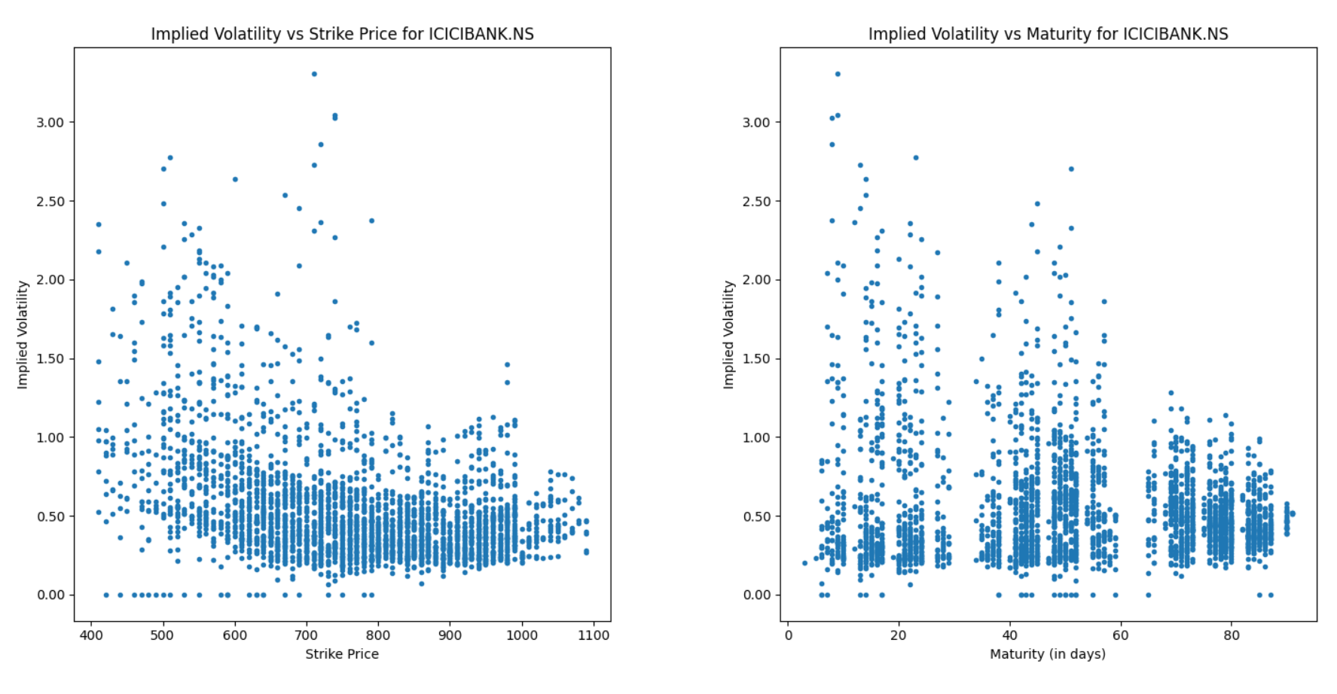

**INFY.NS**

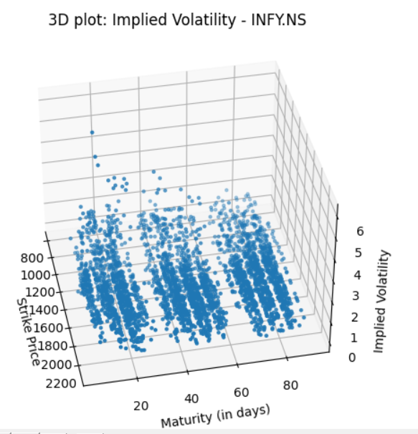

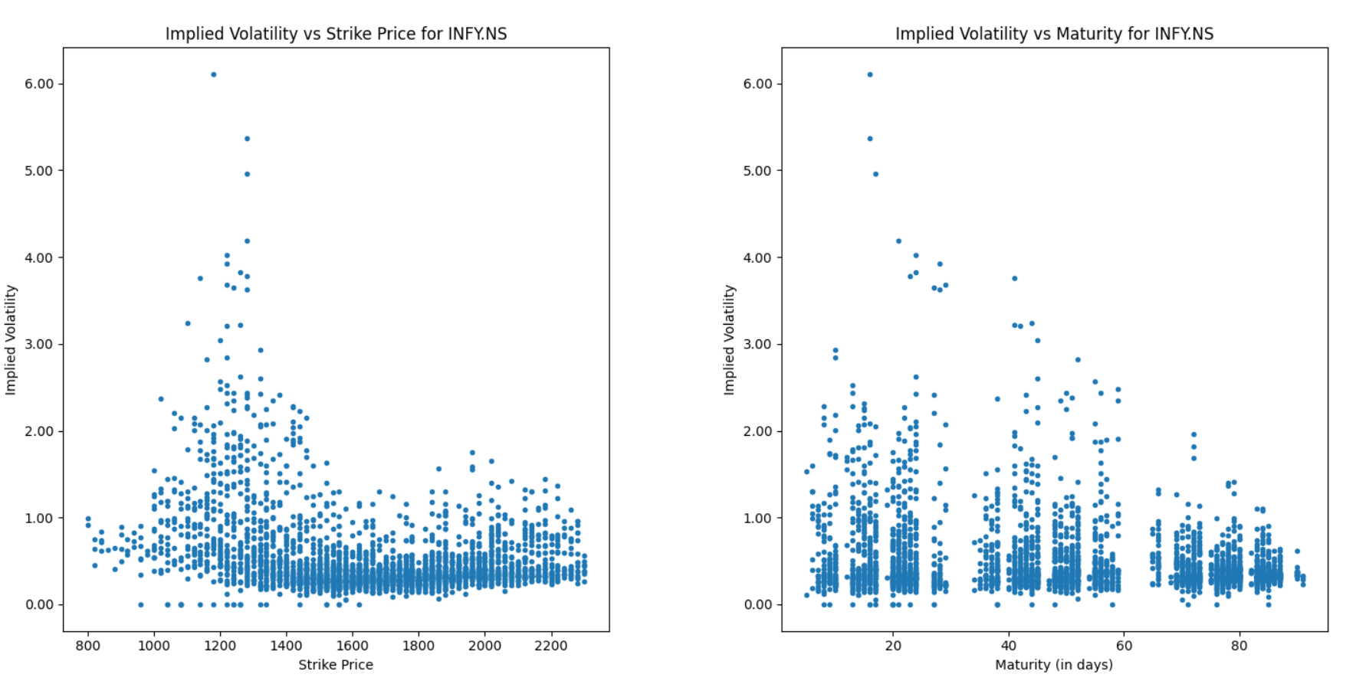

**WIPRO.NS**

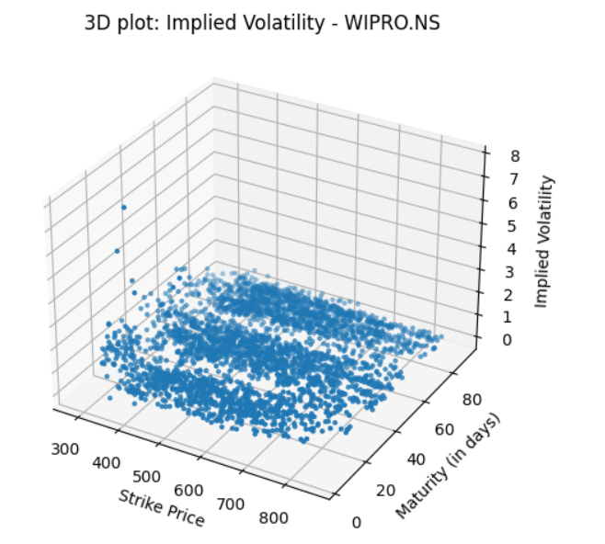

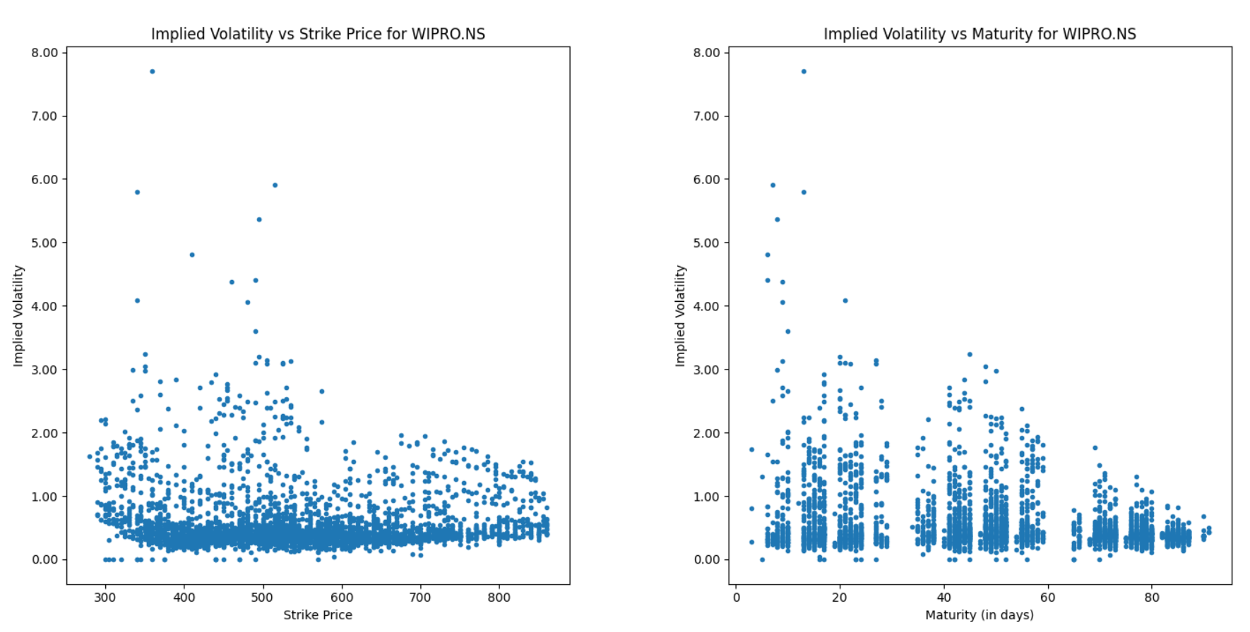

**Observations:**

1. Inadequate data presents challenges in conducting precise analyses, but examining NIFTY50 plots, which have a larger number of data points, allows for the identification of general trends. Other plots demonstrate similar trends.
2. In theory, the Volatility Smile is a curve that exhibits a convex relationship between the implied volatility and strike price. However, this feature is not clearly evident in the plotted curves.
3. Typically, the implied volatility decreases as maturity values increase, but this pattern is not consistently observed in some of the plots mentioned above.

**Q2-c**

**NIFTY50**

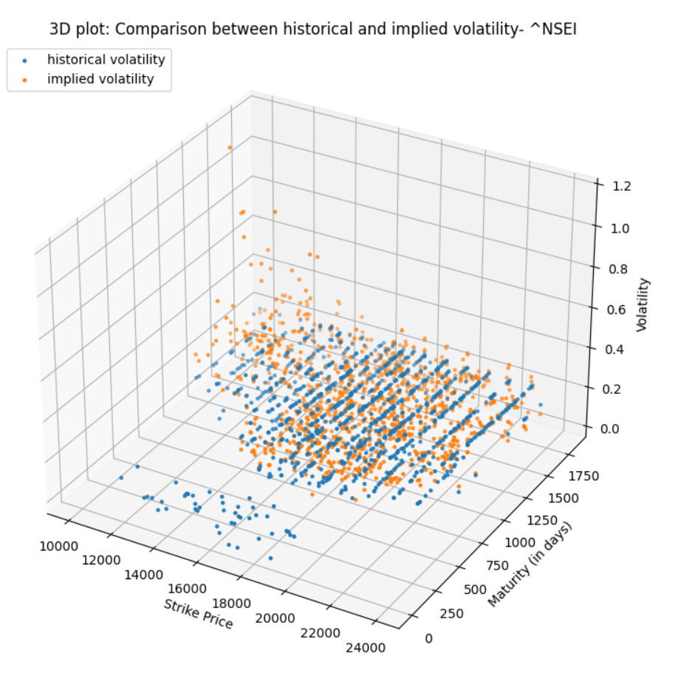 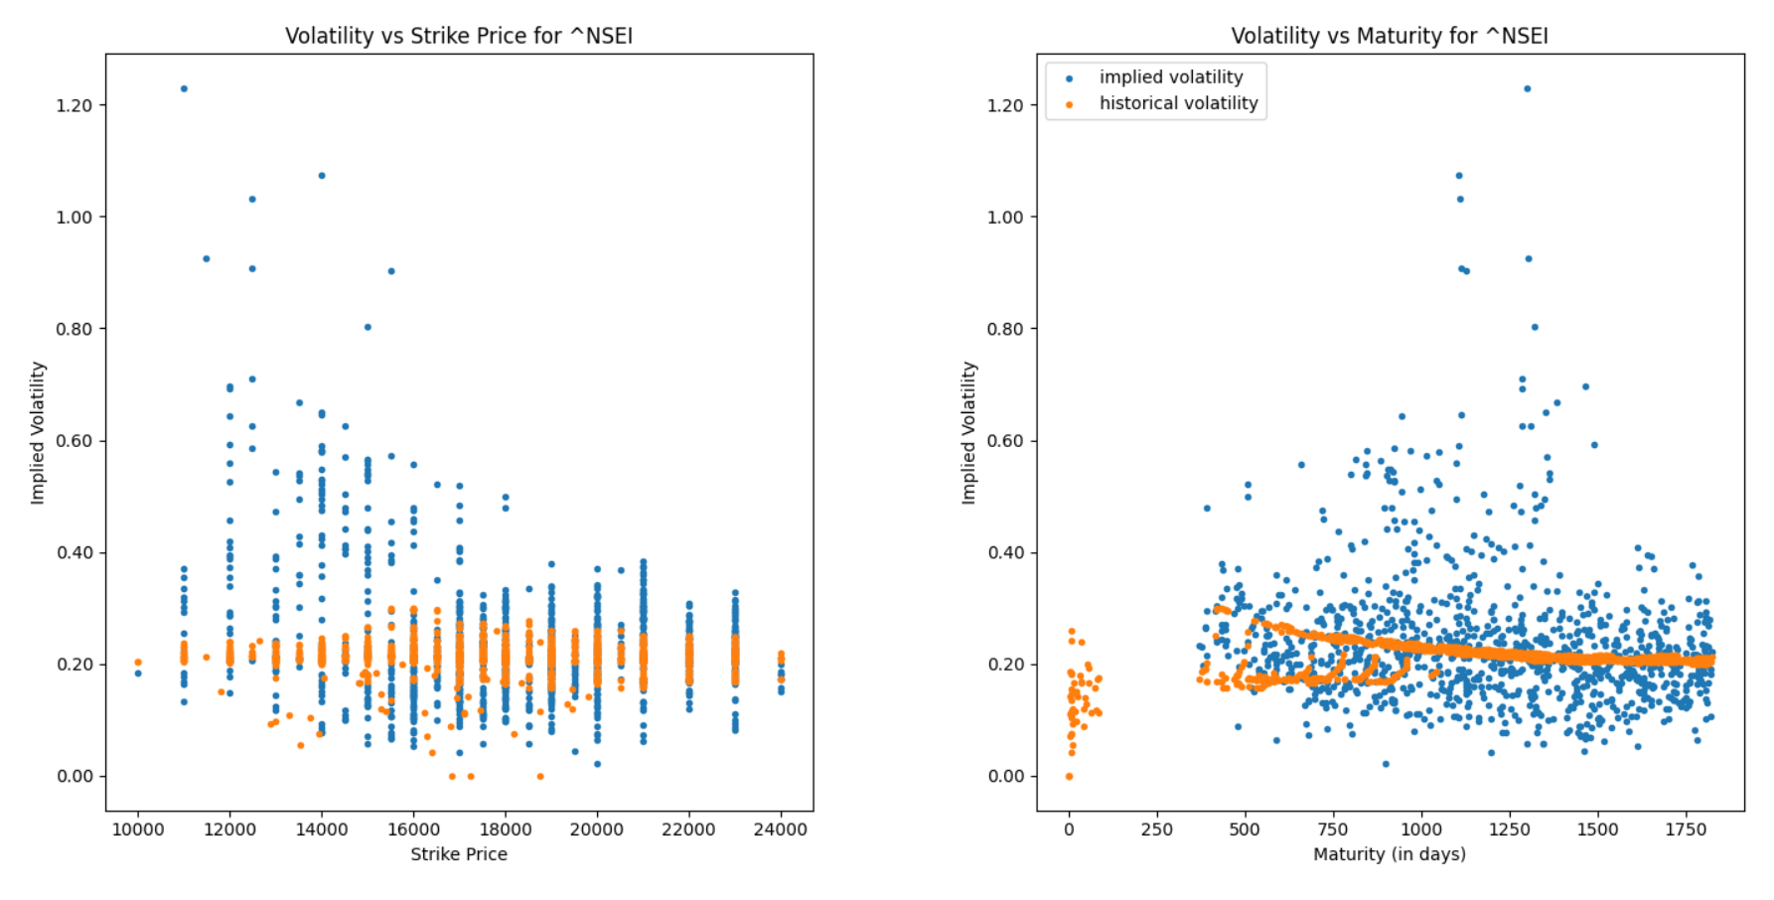

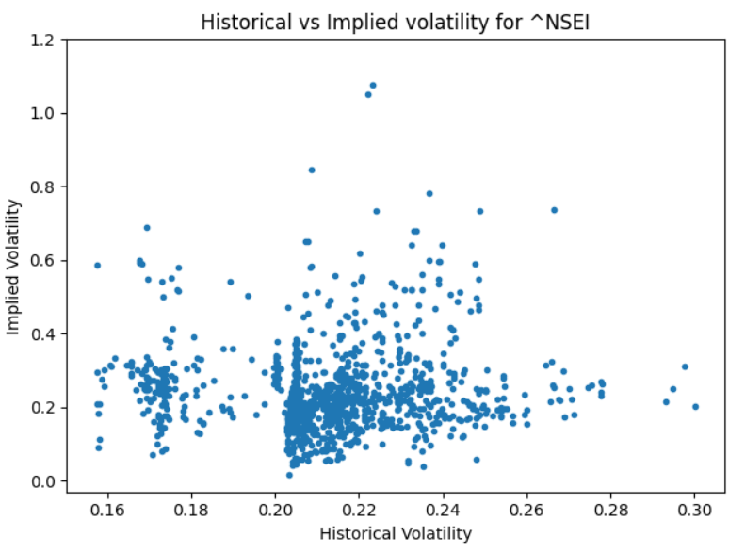 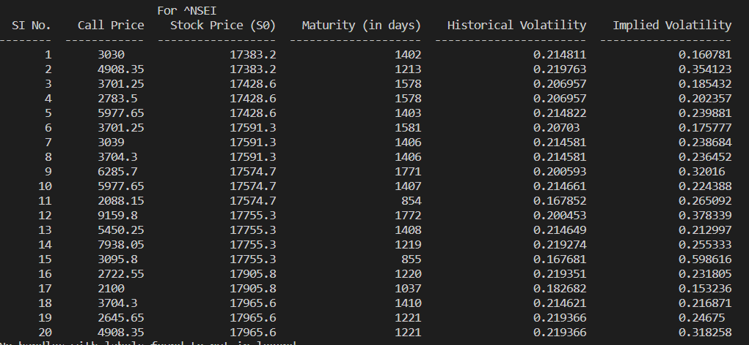

**HDFCBANK.NS**

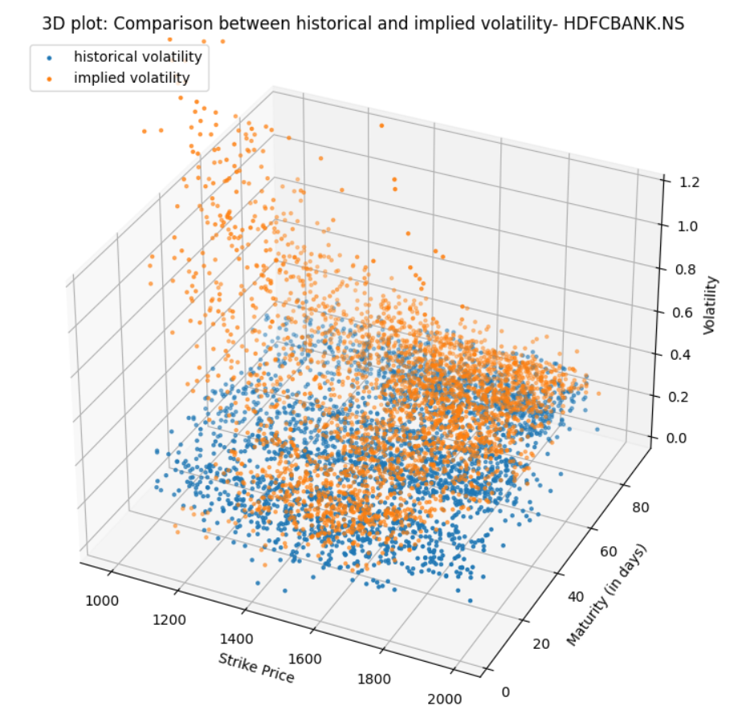

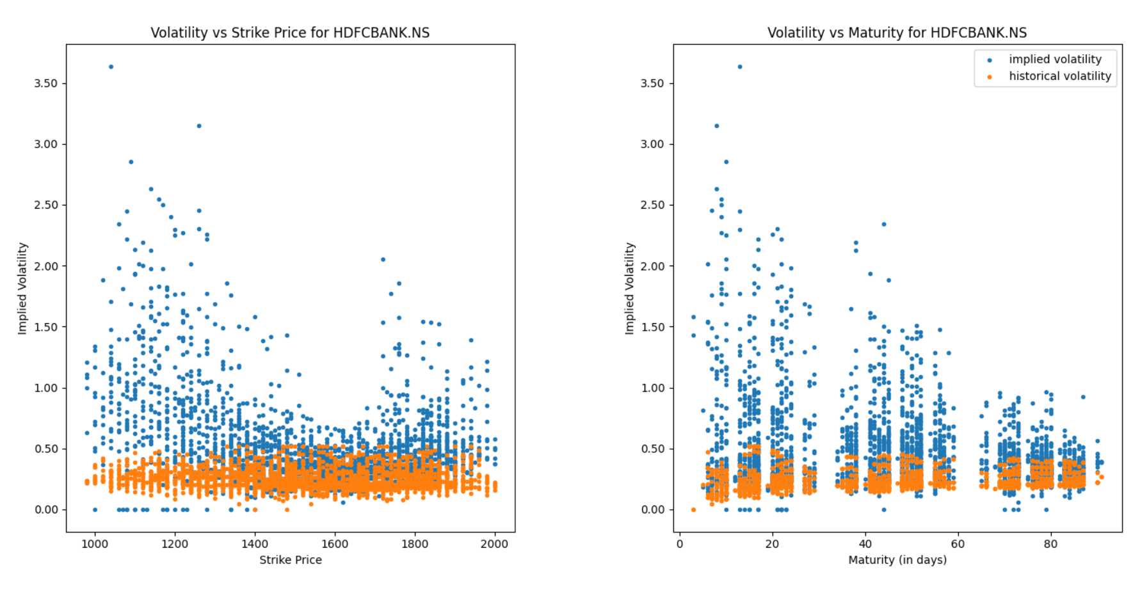 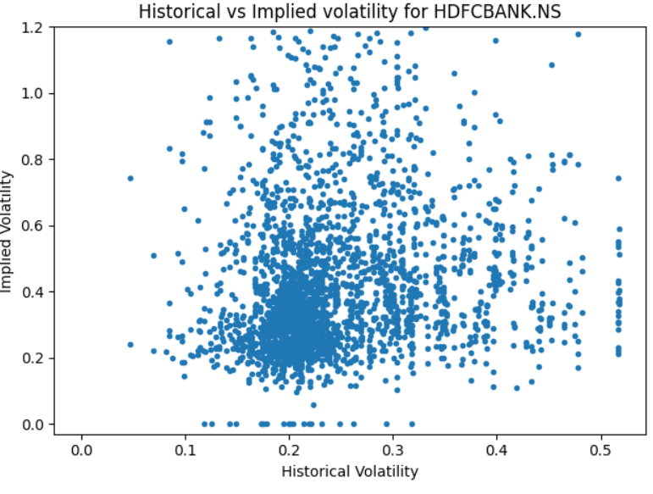

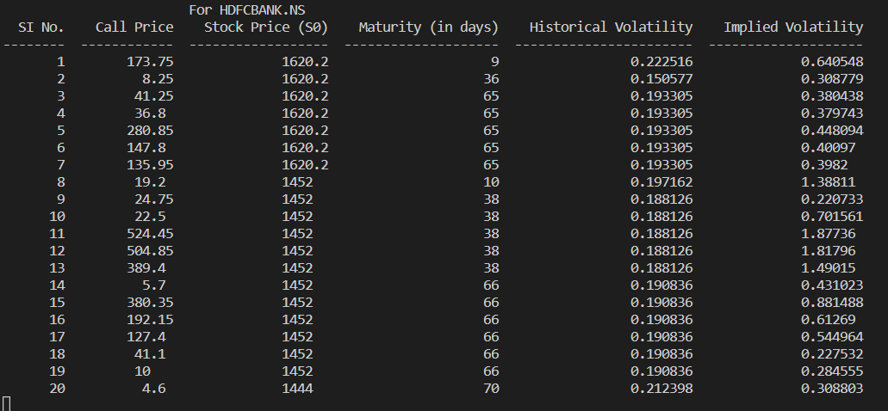

**ICICIBANK.NS**

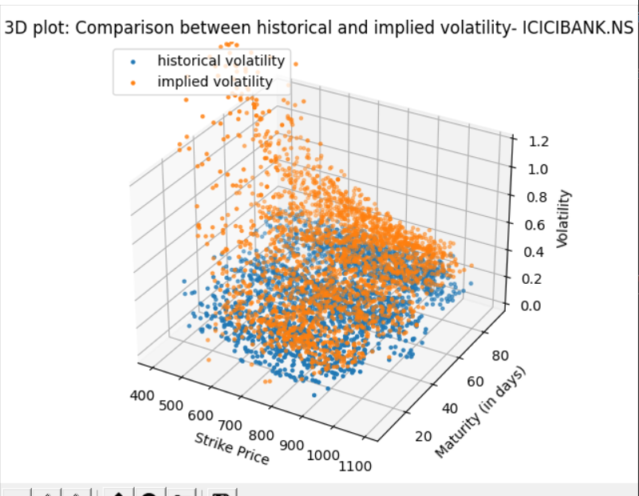

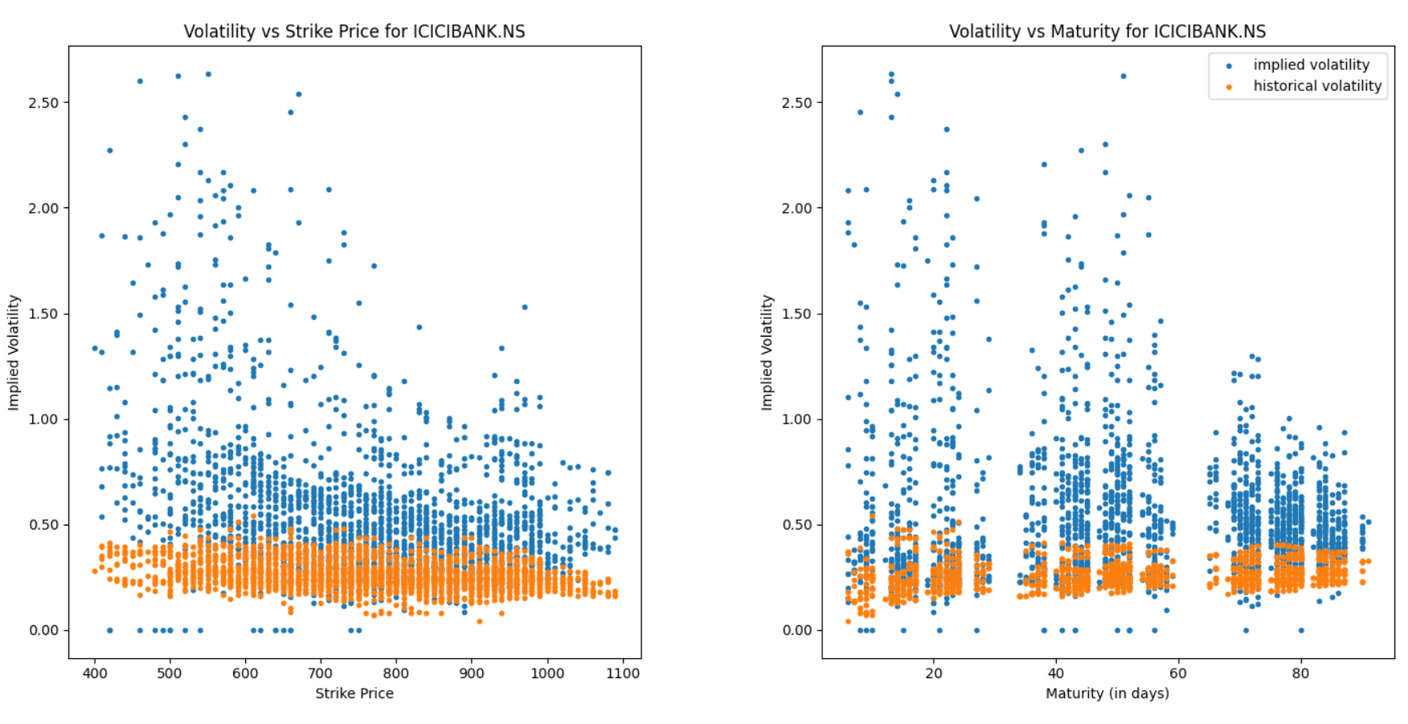

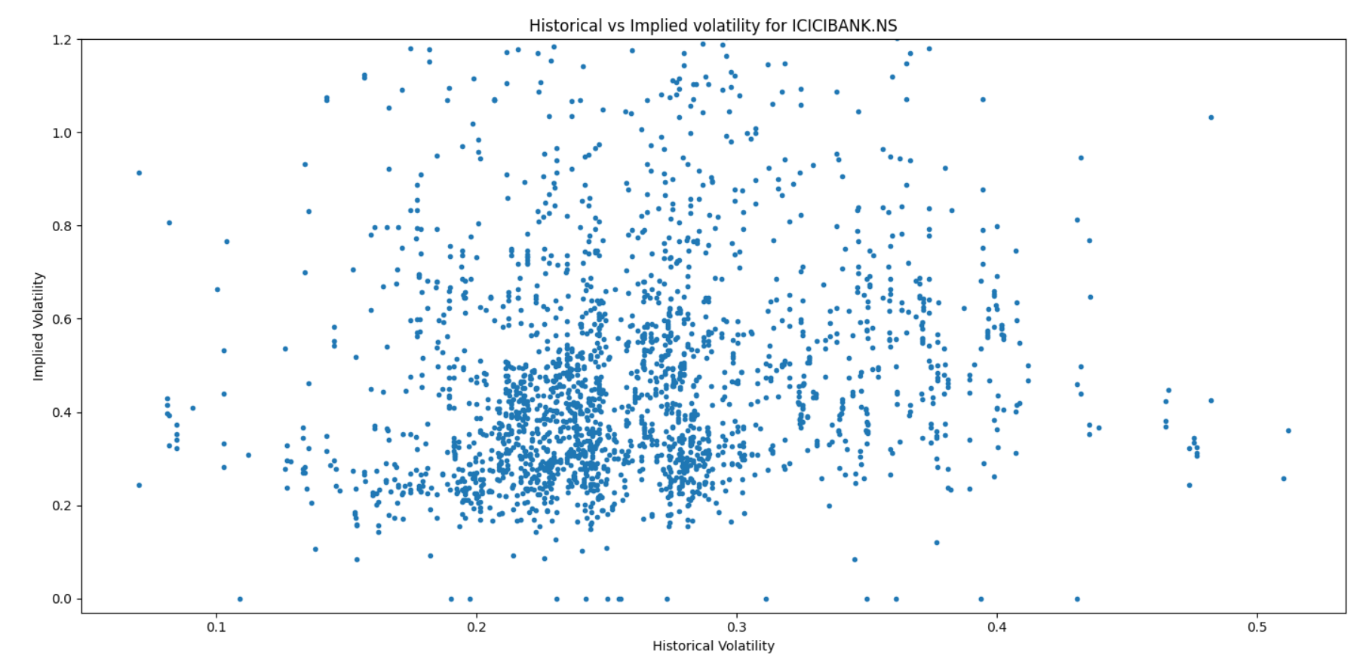

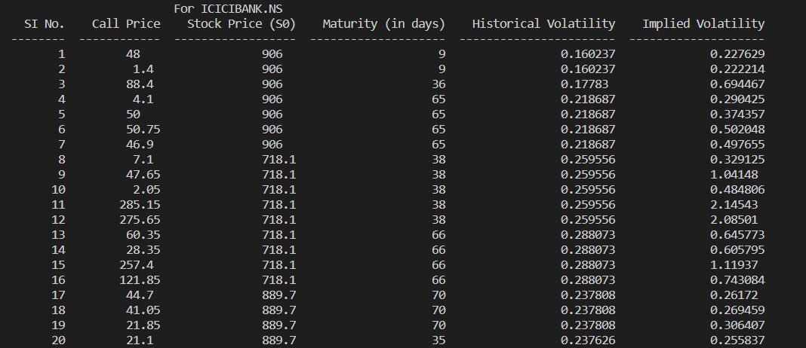

**INFY.NS**

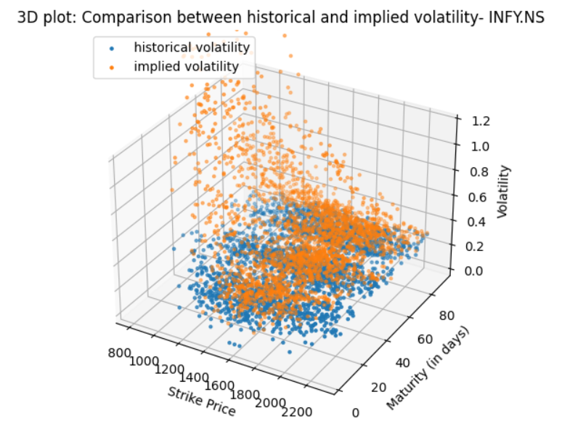

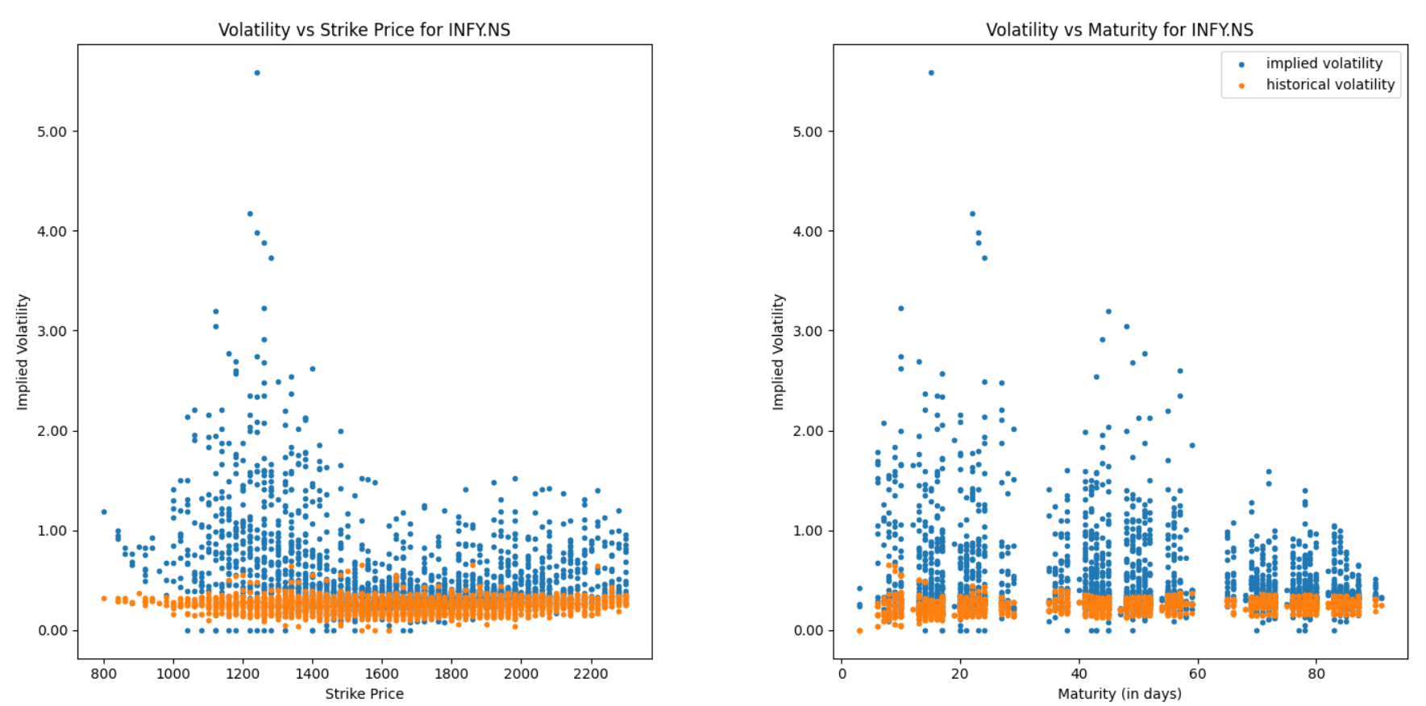

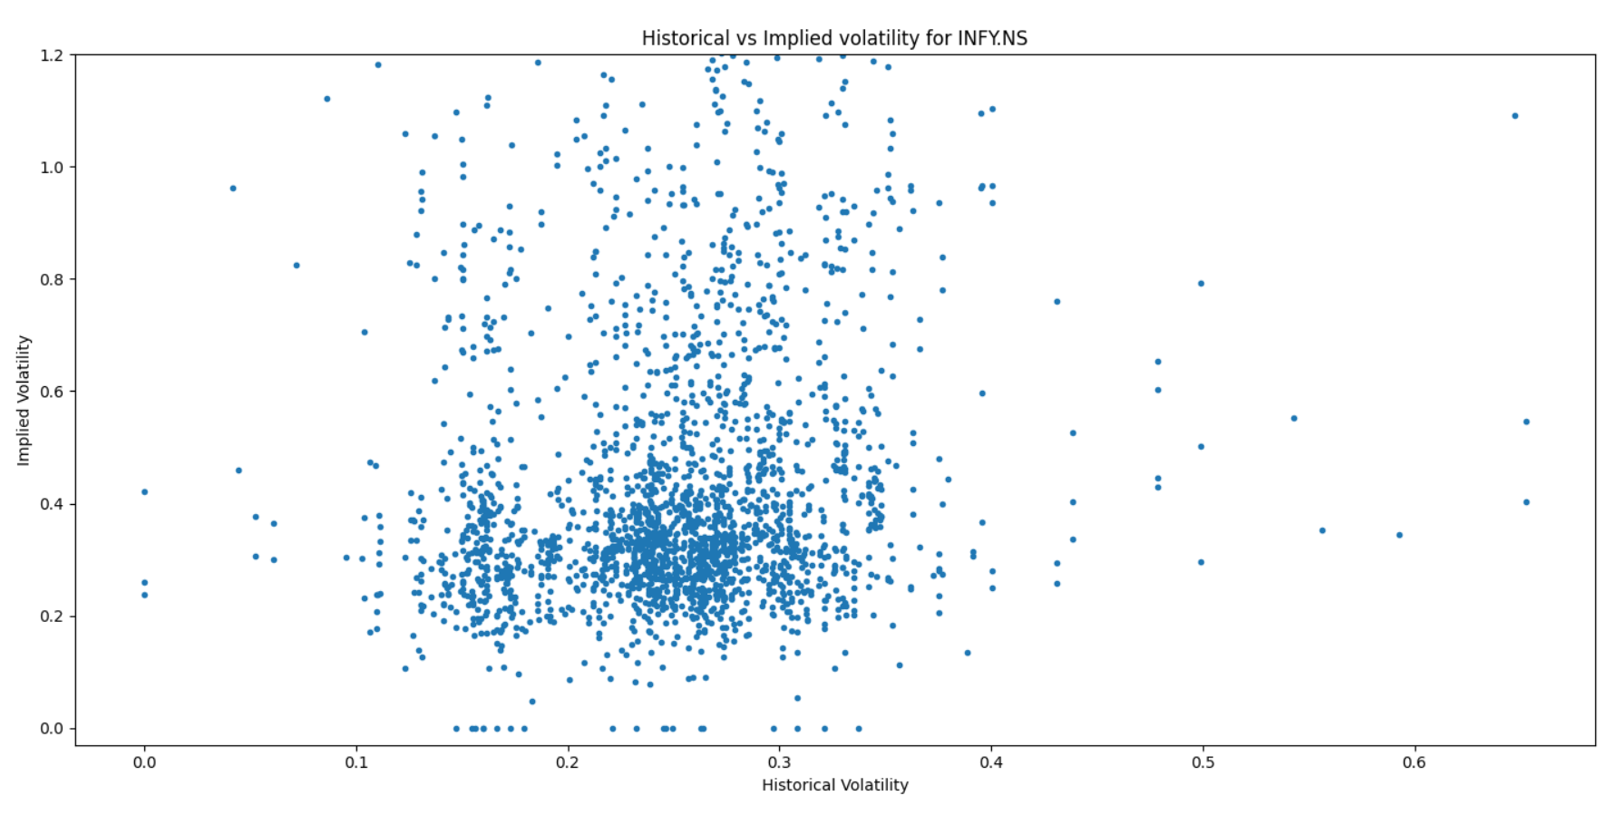

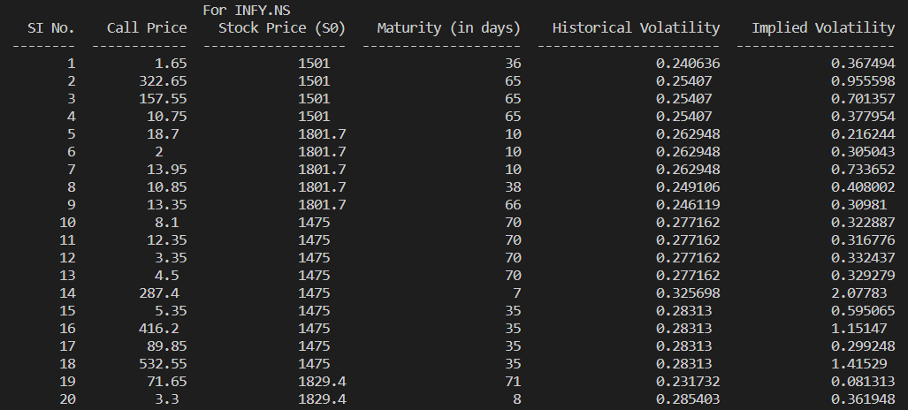

**WIPRO.NS**

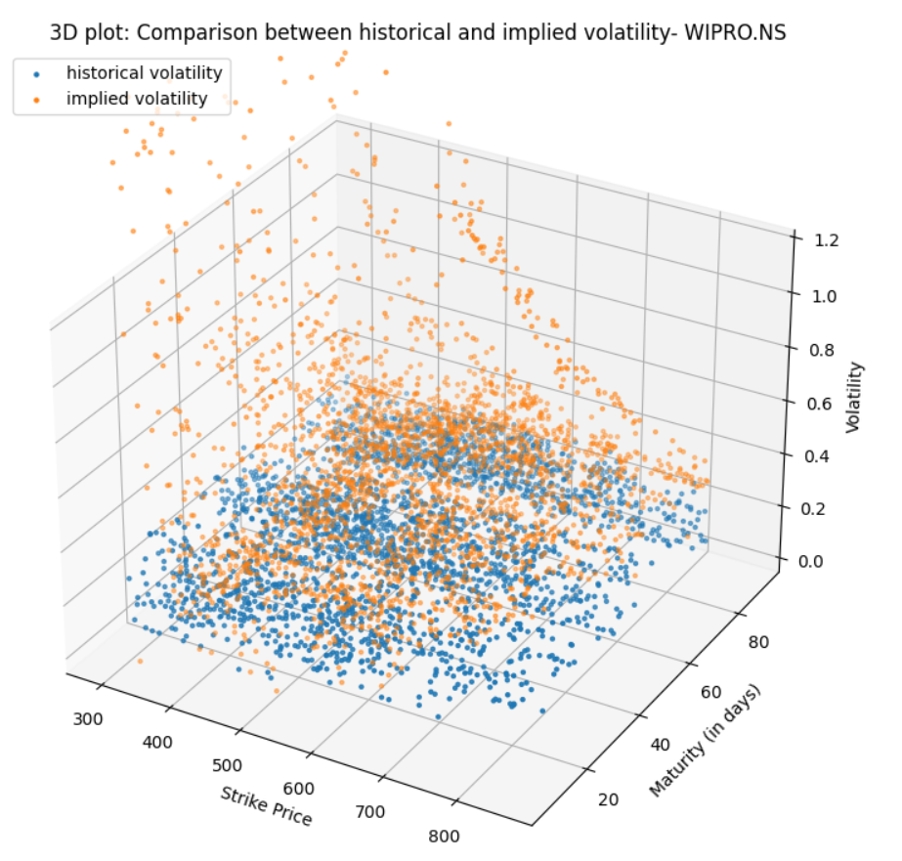

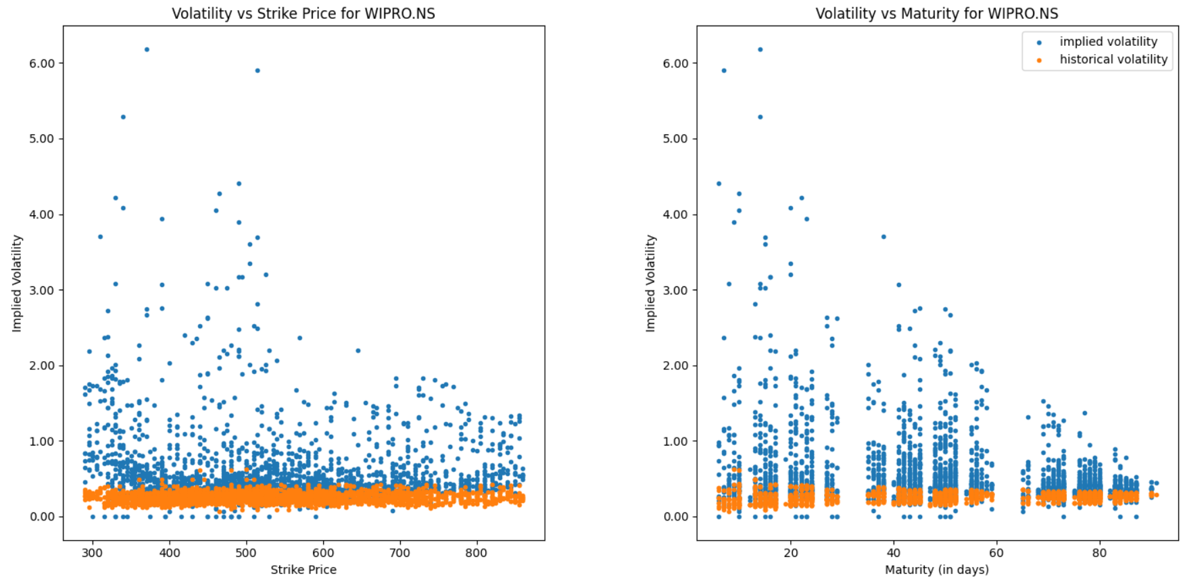

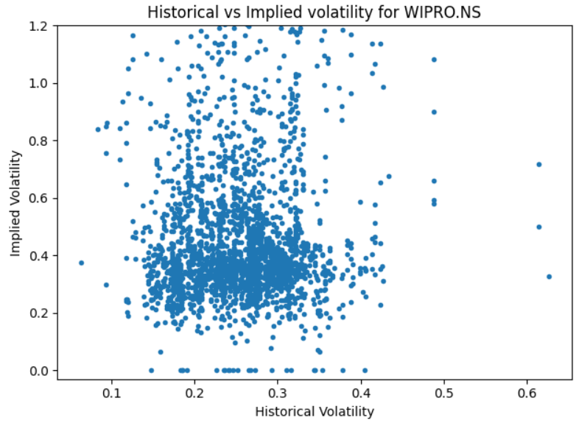

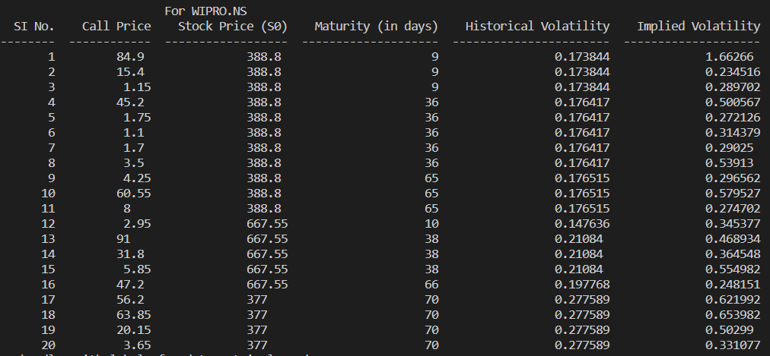

**Observations:**

1. Historical volatility refers to the measurement of volatility over a previous period, whereas implied volatility estimates the volatility for the upcoming months.
2. Approximately, historical volatility should equal implied volatility which is somehow visible from the table but there are some differences also.
3. Implied volatility tends to be higher for stocks like NIFTY50 and RELIANCE, while historical volatility tends to be higher for stocks like BAJAJ-AUTO and TATAMOTORS. The significant difference between these two values arises due to several factors present in the real market.
4. The plot that compares historical and implied volatility effectively captures this relationship, while other plots illustrate the dependency of different types of volatility on varying strike price and maturity.